USP® 180
HT-NS Roofing Underlayment
Maximum 180 Day Exposure
PRODUCT
DATA
SHEET

Physical Properties (ASTM D5147): | Test Results | ASTM D1970 Minimum Standard
Thickness | 42 mills | 40 Mills
Tensile Strength (lbf/in), 73°F (MD/XMD) | 82/112 lbf/in | 25 lbf/in
Elongation (% @ Max Load), 73°F (MD/XMD) | 35 / 39 % | 10%
Adhesion to Plywood, Min at 40°F | 12.5 lbs | 2.0 lbf/ft width
Adhesion to Plywood, Min at 73°F | 60.8 lbs | 12.0 lbf/ft width
Tear Strength (lbf), (MD/XMD), 73°F, minimum | 149 / 132 lbf | 20 lbf
Low Temperature Flexibility, (°F), maximum | -28°F | -20°F
Thermal Stability, maximum | 0.0 in | 0.1 in
Moisture Vapor Permeance, Max | 0.0 Perms | 0.1 U.S. Perms
Sealability around nail | Pass | Pass
Waterproof integrity after Low Temperature Flexibility | Pass | Pass
Waterproof Integrity of Lap Seam  USP® 180 HT-NS replaces the use of #15 or #30 organic roofing felt and is designed for residential use under primary roofing materials such as; asphalt or synthetic shingles, metal, tile, slate, cement, and primed cedar shakes. USP® 180 HT-NS should be stored at temperatures between 50 and 90 degrees, upright indoors, in a dry and ventilated area. USP® 180 HT-NS is applied by removing the poly release film and adhering the membrane by direct pressure contact to the desired substrate. USP® 180 HT-NS has a shelf life of 6 months from the date of manufacture, depending on storage conditions. Improper storage will reduce the shelf life of the product. Warm weather conditions and exposure to direct sunlight are essential for proper adhesion. Application should be made when ambient temperatures are 50°F (10°C) or higher. Note: Self-adhered membranes will not activate if installed in below recommended temperatures and/or if material temperature is below 70°F (21°C). Deck must be clean, dry and free of voids. Cut USP® 180 HT-NS into manageable lengths before installation. Peel back 1 to 2 feet of the release film and stick the membrane directly over the roof deck or insulation, unroll membrane and realign at opposite end. Once set, the film can be removed. Press membrane into substrate to make full contact. Side laps must be a minimum of 3 inches and end laps a minimum of 6 inches. Underlayment Method: Align membrane with the gutter edge and extend coverage at least 3 feet inside the exterior wall or the highest point of damming. Note: When covering the entire roof deck with USP® 180 HT-NS the roof system must include proper ventilation, including both ridge and soffit venting. All installed USP® 180 HT-NS must be covered and not left exposed for more than 180 days. | Pass | Pass
USP® 180 HT-NS is a Self-Adhered High-Temperature Underlayment designed and manufactured to be a secondary waterproofing barrier in sloped roof system. USP® 180 HT-NS is intended to be used where toughness and longer exposure may be required. USP® 180 HT-NS is an air, water and vapor barrier and must be installed above properly ventilated spaces. USP® 180 HT-NS is designed to be left exposed for up to 180 days!

All values given are approximate and are subject to change without notice. There is no implied or express warranty given through these values or statements, nor are there any assertions that the product purchased has been individually tested to conform to these standards. Testing is performed on a random basis by “in-house” and independent “third party” evaluation for the purpose of classification and or approval. Acceptance, purchase and selection of these products are the sole responsibility of the buyer or buyer’s representative. We assume no responsibility for coverage, performance or injuries resulting from use. Liability, if any, is limited to replacement of the product. NO OTHER WARRANTY OR GUARANTEE OF ANY KIND IS MADE BY U.S. PLY, INC. EXPRESSED OR IMPLIED; STATUTORY, BY OPERATION OF LAW, OR OTHERWISE, INCLUDING MERCHANTABILITY AND FITNESS FOR A PARTICULAR PURPOSE.

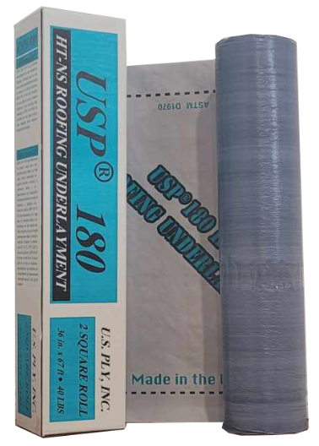

Product Data:
USP® 180 HT-NS (typical)

Thickness:
1.1 mm (45 mils)

Weight:
42.5 lbs/roll (48 kg/m²)

Roll Dimensions:
36”x 67’ (0.91m x 20.4m)

Each roll is approximately
2 square applied

USP® 180 HT-NS is designed for exposure up to 180 days

